Assignment 1
Topic: Factorial and Fibonacci Series using Recursion

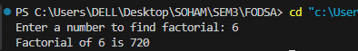
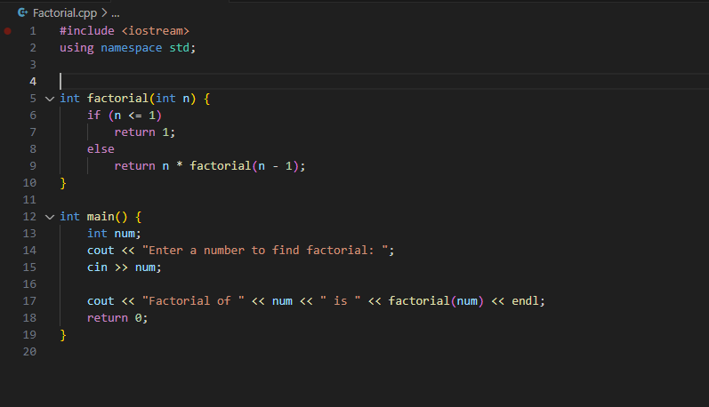
- Factorial of the number:

CODE:
#include <iostream>
using namespace std;

// Recursive function to find factorial
int factorial(int n) {
if (n <= 1)
return 1;
else
return n * factorial(n - 1);
}

int main() {
int num;
cout << "Enter a number to find factorial: ";
cin >> num;

cout << "Factorial of " << num << " is " << factorial(num) << endl;
return 0;
}

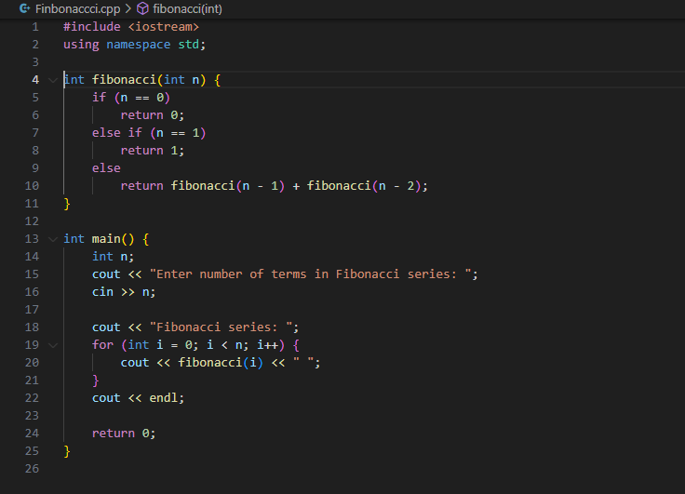
- Fibonacci Series:
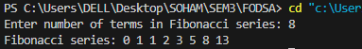
CODE:
#include <iostream>
using namespace std;

int fibonacci(int n) {
if (n == 0)
return 0;
else if (n == 1)
return 1;
else
return fibonacci(n - 1) + fibonacci(n - 2);
}

int main() {
int n;
cout << "Enter number of terms in Fibonacci series: ";
cin >> n;

cout << "Fibonacci series: ";
for (int i = 0; i < n; i++) {
cout << fibonacci(i) << " ";
}
cout << endl;

return 0;
}

